Creating a Custom Adapter Driver for Fusion API
This document describes how to create a custom adapter driver for the Fusion API. An adapter other than the Texas Instruments USB-TO-GPIO hardware can then be used to communicate with a supported SMBus/PMBus device.
Last Updated 3 June 2012
Michael S Muegel

IMPORTANT NOTICE
Texas Instruments and its subsidiaries (TI) reserve the right to make changes to their products or to discontinue any product or service without notice, and advise customers to obtain the latest version of relevant information to verify, before placing orders, that information being relied on is current and complete. All products are sold subject to the terms and conditions of sale supplied at the time of order acknowledgment, including those pertaining to warranty, patent infringement, and limitation of liability.
TI warrants performance of its products to the specifications applicable at the time of sale in accordance with TI’s standard warranty. Testing and other quality control techniques are utilized to the extent TI deems necessary to support this warranty. Specific testing of all parameters of each device is not necessarily performed, except those mandated by government requirements.
Customers are responsible for their applications using TI components.
In order to minimize risks associated with the customer’s applications, adequate design and operating safeguards must be provided by the customer to minimize inherent or procedural hazards.
TI assumes no liability for applications assistance or customer product design. TI does not warrant or represent that any license, either express or implied, is granted under any patent right, copyright, mask work right, or other intellectual property right of TI covering or relating to any combination, machine, or process in which such products or services might be or are used. TI’s publication of information regarding any third party’s products or services does not constitute TI’s approval, license, warranty or endorsement thereof.
Reproduction of information in TI data books or data sheets is permissible only if reproduction is without alteration and is accompanied by all associated warranties, conditions, limitations and notices. Representation or reproduction of this information with alteration voids all warranties provided for an associated TI product or service, is an unfair and deceptive business practice, and TI is not responsible nor liable for any such use.
Resale of TI’s products or services with statements different from or beyond the parameters stated by TI for that product or service voids all express and any implied warranties for the associated TI product or service, is an unfair and deceptive business practice, and TI is not responsible nor liable for any such use.

Also see: Standard Terms and Conditions of Sale for Semiconductor Products. www.ti.com/sc/docs/stdterms.htm

Mailing Address:
Texas Instruments
Post Office Box 655303
Dallas, Texas 75265

Copyright © 2007, Texas Instruments Incorporated

Table of Contents
1 Overview 1
2 Driver Interfaces 2
3 Tips on Developing Your Driver 5
3.1 Factory Class 5
3.2 Driver Class 5
4 Example Driver Classes 6
5 Driver Interfaces 8
5.1 IAdapterDriverFactory 8
5.2 IAdapterDriver 8
5.3 IAdapterDriverExtras 9
5.4 ISMBusAdapterDriver 10
5.5 II2CAdapterDriver 12

- Overview
Starting with Fusion API version 1.8.228 and higher, customers can develop their own driver for alternative SMBus hardware adapters. In a nutshell, you can write some .NET code – a driver -- to allow the Fusion API to communicate through a SMBus adapter other than Texas Instruments USB-TO-GPIO. This document gives an overview of the architecture and code you must implement to create the driver.
The Fusion API was refactored to turn all USB-TO-GPIO code into a driver. But the existing SMBusAdapter class members – properties, fields, methods, and events – where not modified (except for slight name changes to match the coding style of the rest of the Fusion API).
The adapter driver class is something Fusion API end-users normally should not need to know about. It provides the low-level plumbing that the SMBusAdapter class uses. A driver is simply two classes that implement interfaces defined in the TIDP.SAA.dll assembly (and TIDP.SAA namespace).
The following diagram provides a high-level view of the driver classes and interfaces:
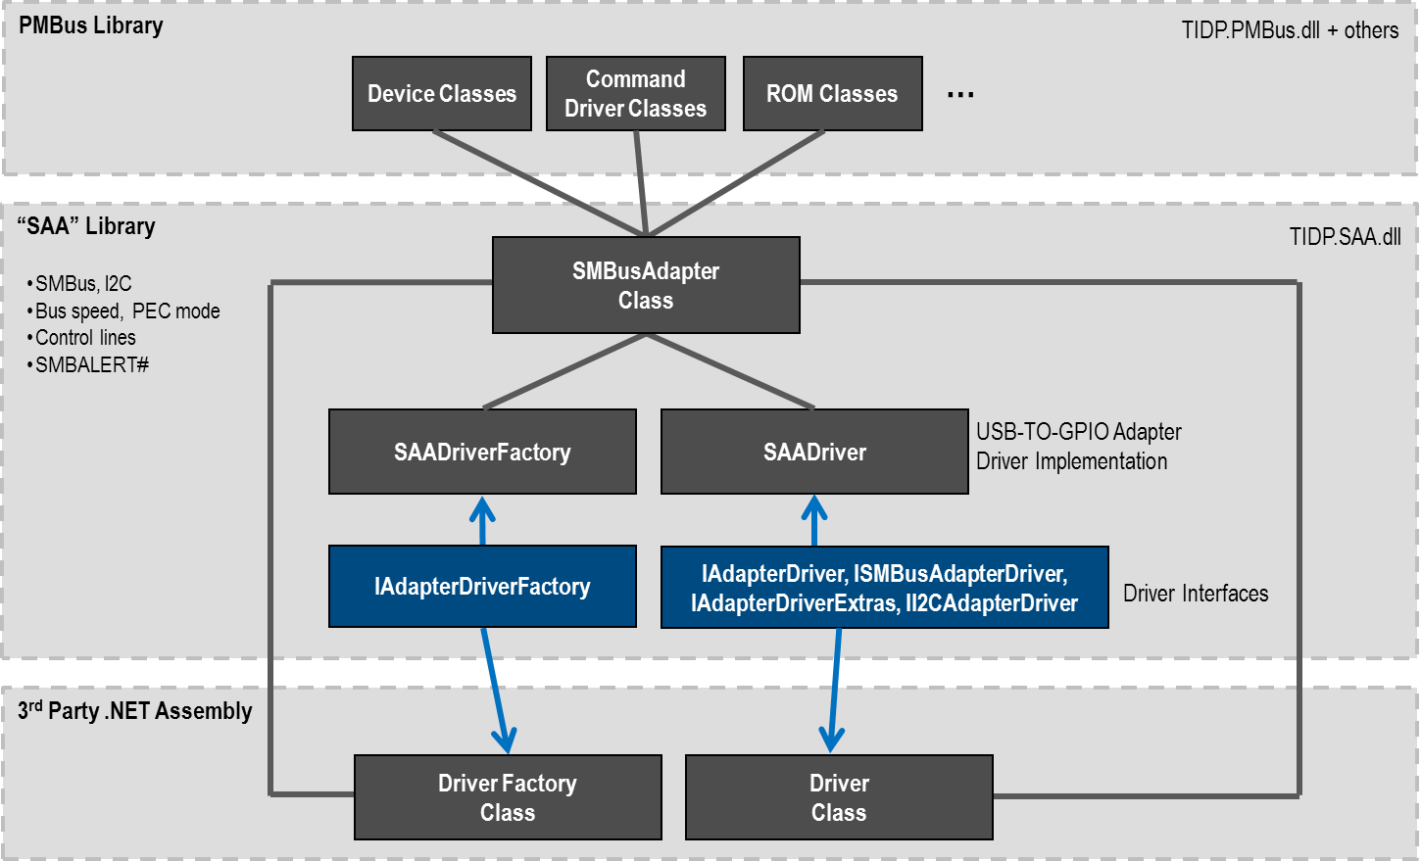
The SMBusAdapter class is now more generic, since it is primarily a wrapper around calling the appropriate driver properties and methods. The SAADriverFactory and SAADriver classes shown are the low-level drivers for the TI USB-TO-GPIO SMBus/I2C adapter that ships with many EVMs that Fusion Digital Power Designer supports.

Driver Interfaces
To create a driver, you need to create two .NET classes:
- A driver factory class that implements TIDP.SAA.IAdapterDriverFactory. This class has a single method that it must implement: Discover(). This returns a list of drivers for all physical adapters that are connected to the PC when the function is called. If no adapters are present that your driver supports, an empty list should be returned. You do not have to support multiple physical adapters. The USB-TO-GPIO driver does support multiple adapters, however, so it can return more than one.
Note that IAdapterDriverFactory.Discover() may be called multiple times in cases where the user did not have the adapter connected, started a tool, and then clicked a “retry” or similar button to look for adapters again. Before IAdapterDriverFactory.Discover() is called a second time, any previously created driver classes (see below) are Disposed of via Dispose().
- A driver class that implements TIDP.SAA.IAdapterDriver and TIDP.SAA.ISMBusAdapterDriver. The IAdapterDriver interface provides some high-level info about the adapter, such as version. ISMBusAdapterDriver provides SMBus and PMBus related communication services, such as read/write byte/word/block and signal read/set. While all methods must be implemented, some are “optional” in that you can return a simple status code indicating your driver does not support a feature. There is also a method provided by the IAdapterDriver interface to query whether a feature is even supported: Is_Feature_Supported(SAAFeature feature). This provides a way for the GUI to disable a feature when not supported by the driver.
Why are there two driver interfaces, IAdapterDriver and ISMBusAdapterDriver, instead of one? There is also an II2CAdapterDriver interface to leave room in the future to support simpler devices that do not support SMBus/PMBus and only support I2C.
There are some optional interfaces that the USB-TO-GPIO driver implements, but which are not required for basic Fusion API functionality (such as discovering a PMBus device, reading its configuration, or programming a configuration). These are:
- TIDP.SAA.IAdapterDriverExtras – as you would guess, this defines some optional properties and methods that an adapter driver could provide. One key optional feature a driver can implement is a method to notify the API that an adapter has been detached or re-attached. The USB-TO-GPIO driver supports this, and fires the AdapterDetached and AdapterReattached events that are defined by this interface to propagate this information throughout the API/toolset. For example, the UCD3xxx Device GUI informs the user via a log warning when the adapter is detached and re-attached.
- TIDP.SAA.II2CAdapterDriver – I2C read/write methods. These are generally not used in the Fusion API for communications, but there is a SMBus/I2C Debug GUI that provides I2C read/write, so the USB-TO-GPIO driver implements these functions. Similar functions are of course available in the SMBusAdapter interface.
Section 5, Driver Interfaces, provides a listing of the interfaces and provides more detail on each class member that must be defined.
The full list of interfaces is shown in the following diagram. A reminder that only the IAdapterDriverFactory interface and IAdapterDriver/ISMBusAdapterDriver interfaces must be implemented (by two different classes).
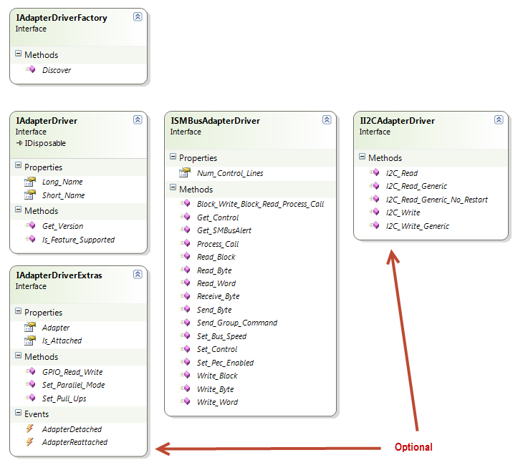
Within ISMBusAdapterDriver, most methods that perform some adapter activity return a SAAStatus enumeration value. If your adapter does not support a feature, SAAStatus.UnsupportedFeature should be returned.
For read/write of a device configuration via SMBus/PMBus, only a subset of the methods in ISMBusAdapterDriver must be fully fleshed out. The following table breaks down the interface more fully:
ISMBusAdapterDriver members that must be fully fleshed out for PMBus command read/write to work: | SAAStatus Read_Byte(byte addr, byte cmd_code, out byte data);  SAAStatus Read_Word(byte addr, byte cmd_code, out byte hi_byte, out byte lo_byte);  SAAStatus Read_Block(byte addr, byte cmd_code, out byte[] data);  SAAStatus Write_Byte(byte addr, byte cmd_code, byte data_byte);  SAAStatus Write_Word(byte addr, byte cmd_code, byte hi_byte, byte lo_byte);  SAAStatus Write_Block(byte addr, byte cmd_code, int len, byte[] data);  // Used to read the SMBUS_ALERT command in PMBus 1.2; used in select TI  // controllers, consult data sheet to see if required  SAAStatus Block_Write_Block_Read_Process_Call(byte addr, byte cmd_code, int byteCount, byte[] writeBlock, out byte[] readBlock);
ISMBusAdapterDriver members that are generally useful in end-device monitoring and operation | SAAStatus Get_SMBusAlert(out LogicLevel logic_level);  // Return 0 if you do not support any  int Num_Control_Lines { get; }  SAAStatus Get_Control(int control_line_number, out LogicLevel logic_level);  SAAStatus Set_Control(int control_line_number, LogicLevel logic_level);  Note that for certain UCD devices and device ON_OFF_CONFIG settings, being able to turn off the CONTROL line would be required to stop power conversion on a rail and reconfigure other commands.
ISMBusAdapterDriver members that provide control over SMBus | SAAStatus Set_Bus_Speed(SMBusAdapter.BusSpeed speed);  SAAStatus Set_Pec_Enabled(bool enabled);  Your driver could chose to only support a single I2C bus speed and also force whether PEC is used in SMBus. In these cases you would return InvalidArgument when an unsupported mode is requested. NOTE that the “ROM” of UCD9xxx/UCD3xxx devices requires PEC. So if you plan on doing any firmware download via API, your driver must support PEC mode and must return SAAStatus.Success when Set_Pec_Enabled(true) is called.
ISMBusAdapterDriver members that are rarely or never used in Fusion tools. It is safe to return UnsupportedFeature for these. | // Currently not used anywhere in Fusion tools or API  SAAStatus Receive_Byte(byte addr, out byte data);  // Currently not used anywhere in Fusion tools or API  SAAStatus Process_Call(byte addr, byte cmd_code, byte writeHi, byte writeLo,  out byte readHi, out byte readLo);  // Only used by a stand-alone group command protocol tester  SAAStatus Send_Group_Command(byte[] group);

Tips on Developing Your Driver

Factory Class
The USB-TO-GPIO driver factory class, SAADriverFactory, provides a simple example of how your factory might work. This is the code:
/// <summary>
/// This searches for USB-TO-GPIO adapters on the PC and creates a driver
/// instance for each that is found.
/// </summary>
public class SAADriverFactory : IAdapterDriverFactory
{
protected const UInt16 HID_VENDOR_ID = 0x451;
protected const UInt16 HID_PRODUCT_ID = 0x5F00;

public IList<IAdapterDriver> Discover()
{
var drivers = new TIList<IAdapterDriver>();

foreach (var device in HidDeviceFactory.Enumerate(
HID_VENDOR_ID, HID_PRODUCT_ID))
{
var driver = new SAADriver(device);
drivers.Add(driver);
}

return drivers;
}
}
The Discover() function iterates over all USB-HID devices that match the USB-TO-GPIO’s vendor and product ID. For each low-level HID device created by the HID library, a SAADriver is created and added to a list of drivers. The list is returned by Discover(). If no drivers were found, you should return an empty list.

Driver Class
PEC is handled by your driver, not the higher level SMBusAdapter API. A static function to calculate the PEC byte is available in the TIDP.BitUtils.SMBus_CRC8() function, which is in the TIDP.Misc.dll assembly.

Example Driver Classes
The ConsoleSample1 project that is bundled with the Fusion API installer provides a sample driver implementation. The driver does not actually work with any real adapter hardware: it instead emulates a TPS53819 controller that is located at PMBus address 100 decimal. The driver ACKs commands the TPS53819 supports, and NACKs commands that it does not. The code is contained in the CustomAdapterDriver folder in the ConsoleSample1 C# project:
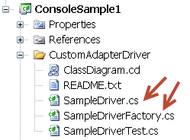
The sample driver only implements IAdapterDriver and ISMBusAdapterDriver, and does not provide the extended features that the built-in USB-TO-GPIO SAADriver implements.
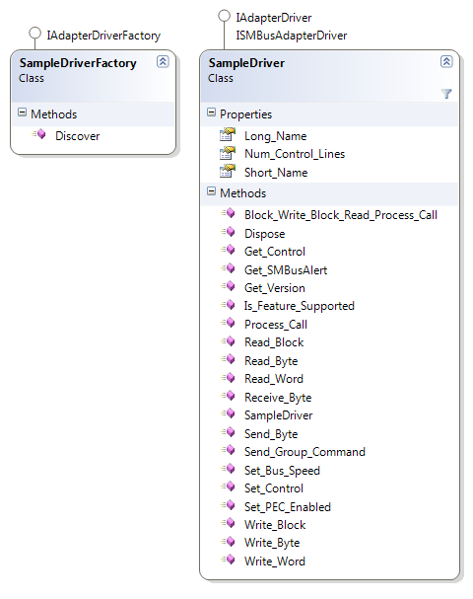
The SampleDriverTest.cs file loads the sample driver and then performs standard Fusion API activities to discover an adapter, discover a device, and then perform some operations against the device. To register the custom adapter driver:
SMBusAdapter.Register_Driver(new SampleDriverFactory());
That is the only “special” code required to use the custom adapter driver.
To run the SampleDriverTest test code from Visual Studio or C# Express:
- Right click the ConsoleSample1 project and select Properties
- Click the Debug tab and enter “custom-adapter-driver” in Command line arguments:
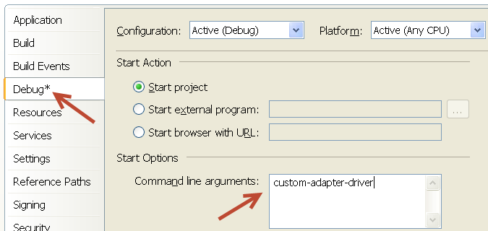
- Run the ConsoleSample1 project

Driver Interfaces

IAdapterDriverFactory
using System.Collections.Generic;

namespace TIDP.SAA
{
public interface IAdapterDriverFactory
{
/// <summary>
/// Looks for adapters present on the PC that are supported. Creates an
/// IAdapterDriver for each adapter found. The implementation must allow
/// this to be called multiple times in the case of initial failure or to
/// rescan for hardware change. Return an empty list if no adapters were found.
/// </summary>
IList<IAdapterDriver> Discover();
}
}

IAdapterDriver
using System;
namespace TIDP.SAA
{
/// <summary>
/// Base interface for a communications adapter driver supported by the Fusion toolset.
/// </summary>
/// <remarks>
/// Note that you also must implement Dispose() via the IDisposable base
/// interface. This will be called when Discover() is called a second time
/// and we first Dispose() of any existing drivers.
/// </remarks>
public interface IAdapterDriver : IDisposable
{
/// <summary>
/// Return the adapter version. Preference is to return the hardware
/// or firmware version of the adapter. If this is not available, return the
/// software driver version. This is only generally called once and is then cached by
/// SMBusAdapter. If there was an error fetching the version from your adapter,
/// return SAAStatus.InvalidResponse.
/// </summary>
SAAStatus Get_Version(out Version version);

/// <summary>
/// A short name for the device in general. For example, USB-TO-GPIO driver
/// currently returns "USB-TO-GPIO".
/// </summary>
string Short_Name { get; }

/// <summary>
/// A long name for the discovered adapter. It should be unique for each
/// adapter if multiple adapters on the device are supported. For example, USB-TO-GPIO driver
/// currently returns something like "USB-TO-GPIO \\?\hid#vid_0451&amp;pid_5f00#6&amp;309601ea&amp;0&amp;0000#{4d1e55b2-f16f-11cf-88cb-001111000030}",
/// which contains the USB-HID identifier of the adapter.
/// </summary>
string Long_Name { get; }

/// <summary>
/// Provides a way for SMBusAdapter and others to query whether a particular optional
/// feature is available.
/// </summary>
bool Is_Feature_Supported(SAAFeature feature);
}
}

IAdapterDriverExtras
using System;

namespace TIDP.SAA
{
public interface IAdapterDriverExtras
{
/// <summary>
/// Return true if the adapter is still attached to PC, false if it is not.
/// When false is returned, SMBusAdapter will skip trying to
/// call the driver and instead return SAAStatus.AdapterDetached. This
/// property is also used used when SMBusAdapter.Is_Attached is invoked.
/// Return true always if you do not support detection of adapter detach.
/// </summary>
bool Is_Attached { get; }

/// <summary>
/// Fire this event when the adapter is detcached from the PC and you can support
/// re-attach. Optional. When fired, the SMBusAdapter layer will automatically
/// fail any adapter requests.
/// </summary>
event EventHandler AdapterDetached;

/// <summary>
/// Fire when the adapter is re-attached to the PC and the driver can again
/// be used. Optional. If you raise AdapterDetached events, be sure to raise
/// AdapterReattached events as well.
/// </summary>
event EventHandler AdapterReattached;

/// <summary>
/// The Fusion API will inform the adapter driver what SMBusAdapter it has been
/// assigned to if you implement IAdapterDriverOptional. You likely will not
/// need the reference to the parent adapter, so your implementation could
/// just ignore the assignment.
/// </summary>
SMBusAdapter Adapter { set; }

/// <summary>
/// Enable/disable parallel mode for I2C communication. This mode
/// is supported by select UCD92xx controllers. Support for this is optional. Return
/// SAAStatus.UnsupportedFeature if you do not support parallel mode. If
/// your driver does support parallel mode, return SAAStatus.Success if you
/// could enable parallel mode.
/// </summary>
SAAStatus Set_Parallel_Mode(bool enabled);

/// <summary>
/// Set the pullup resistors for CLOCK, DATA, and SMBALERT#. This is very focused
/// on USB-TO-GPIO. Optional. Return SAAStatus.UnsupportedFeature if you do not support
/// pullups or have some other way of setting (for example, because your driver has
/// different pullup resistor values).
/// </summary>
SAAStatus Set_Pull_Ups(SMBusAdapter.PullupValues pullups);

/// <summary>
/// Read/write GPIOs. This is very focused on USB-TO-GPIO. Optional. Return
/// SAAStatus.UnsupportedFeature if you do not support
/// </summary>
SAAStatus GPIO_Read_Write(byte readMask, byte writeData, ref byte readData);
}
}

ISMBusAdapterDriver
namespace TIDP.SAA
{
/// <summary>
/// Defines an interface for a hardware adapter that will process SMBus
/// requests. See parent interface, IAdapterDriver, for additional
/// members.
/// </summary>
/// <remarks>
/// The SAAStatus status codes indicate success/failure of each request.
/// Success should be used to indicate ACK. InvalidResponse should be
/// used to indicate NACK. If the physical adapter is not responding after
/// Discover() was previously called succesfully, DriverError should be
/// returned from a call. If there is a PEC mismatch, InvalidPEC should
/// be returned (this is a new enum in SAAStatus).
/// <para/>
/// PEC byte is never included in data passed into the functions and
/// returned from the functions. For writes, address does not include
/// shifting of address to account for I2C write protocol.
/// </remarks>
public interface ISMBusAdapterDriver
{
/// <summary>
/// SMBus receive byte. This is not required for PMBus read/write and
/// is not used in Fusion. Implementation is optional: return
/// UnsupportedFeature if not supported.
/// </summary>
SAAStatus Receive_Byte(byte addr, out byte data);

/// <summary>
/// SMBus read byte. Required.
/// </summary>
SAAStatus Read_Byte(byte addr, byte cmd_code, out byte data);

/// <summary>
/// SMBus read byte. Required.
/// </summary>
SAAStatus Read_Word(byte addr, byte cmd_code, out byte hi_byte, out byte lo_byte);

/// <summary>
/// SMBus read block. Required.
/// </summary>
SAAStatus Read_Block(byte addr, byte cmd_code, out byte[] data);

/// <summary>
/// SMBus send byte. Required.
/// </summary>
SAAStatus Send_Byte(byte addr, byte cmd_code);

/// <summary>
/// SMBus write byte. Required.
/// </summary>
SAAStatus Write_Byte(byte addr, byte cmd_code, byte data_byte);

/// <summary>
/// SMBus write word. Required.
/// </summary>
SAAStatus Write_Word(byte addr, byte cmd_code, byte hi_byte, byte lo_byte);

/// <summary>
/// SMBus write block. Required.
/// </summary>
SAAStatus Write_Block(byte addr, byte cmd_code, int len, byte[] data);

/// <summary>
/// SMBus process call. Optional. Return SAAStatus.UnsupportedFeature if your driver
/// does not support.
/// </summary>
SAAStatus Process_Call(byte addr, byte cmd_code, byte writeHi, byte writeLo,
out byte readHi, out byte readLo);

/// <summary>
/// SMBus Block write-block read process call. Optional. Return
/// SAAStatus.UnsupportedFeature if your driver does not support.
/// </summary>
SAAStatus Block_Write_Block_Read_Process_Call(byte addr, byte cmd_code, int byteCount,
byte[] Write_Block, out byte[] Read_Block);

/// <summary>
/// Sets I2C bus speed (100 kHz or 400 kHZ). Return SAAStatus.UnsupportedFeature
/// if your driver does not support the bus speed passed.
/// </summary>
SAAStatus Set_Bus_Speed(SMBusAdapter.BusSpeed speed);

/// <summary>
/// Defines whether PEC byte is sent on SMBus write and verified on SMBus read.
/// </summary>
SAAStatus Set_PEC_Enabled(bool enabled);

/// <summary>
/// Gets the value of the SMBALERT# line. Return SAAStatus.UnsupportedFeature if
/// your driver does not support SMBALERT#.
/// </summary>
SAAStatus Get_SMBusAlert(out LogicLevel logic_level);

/// <summary>
/// Gets the value of the specified control line. control_line_number should be 1 to 5.
/// Return SAAStatus.UnsupportedFeature if your driver does not support
/// any control lines. Return SAAStatus.InvalidArgument if you do not support the
/// specified control line.
/// </summary>
SAAStatus Get_Control(int control_line_number, out LogicLevel logic_level);

/// <remarks>
/// Sets the CONTROL line specified, numbered 1 to 5. Leaves other lines alone.
/// Return SAAStatus.UnsupportedFeature if your driver does not support
/// any control lines. Return SAAStatus.InvalidArgument if you do not support the
/// specified control line.
/// </remarks>
SAAStatus Set_Control(int control_line_number, LogicLevel logic_level);

/// <summary>
/// Returns the number of control lines supported by the driver/adapter. Return 0
/// if none are supported.
/// </summary>
int Num_Control_Lines { get; }

/// <summary>
/// Send a Group Command Protocol request, as described in the PMBus specification, Part I.
/// Optional. Return SAAStatus.UnsupportedFeature if your driver does not support the
/// group command protocol. Group command protocol is not generally exposed in Fusion
/// Digital Power Designer.
/// </summary>
/// <remarks>
/// This is not technically SMBus, but it seems overkill to create an interface for this single
/// method.
/// </remarks>
SAAStatus Send_Group_Command(byte[] group);
}
}

II2CAdapterDriver
namespace TIDP.SAA
{
public interface II2CAdapterDriver
{
SAAStatus I2C_Read(byte addr, byte command, int dataLen, out byte[] data);
SAAStatus I2C_Write(byte addr, byte command, int dataLen, byte[] data);
SAAStatus I2C_Read_Generic(int numBytesToWrite, byte[] dataWrite, byte lastWriteByte, int numBytesToRead, ref byte[] dataRead);
SAAStatus I2C_Write_Generic(int dataLen, params byte[] data);
SAAStatus I2C_Read_Generic_No_Restart(byte address, int numBytesToRead, ref byte[] data);
}
}

